**OUTPUT**

Case 1: From available choices

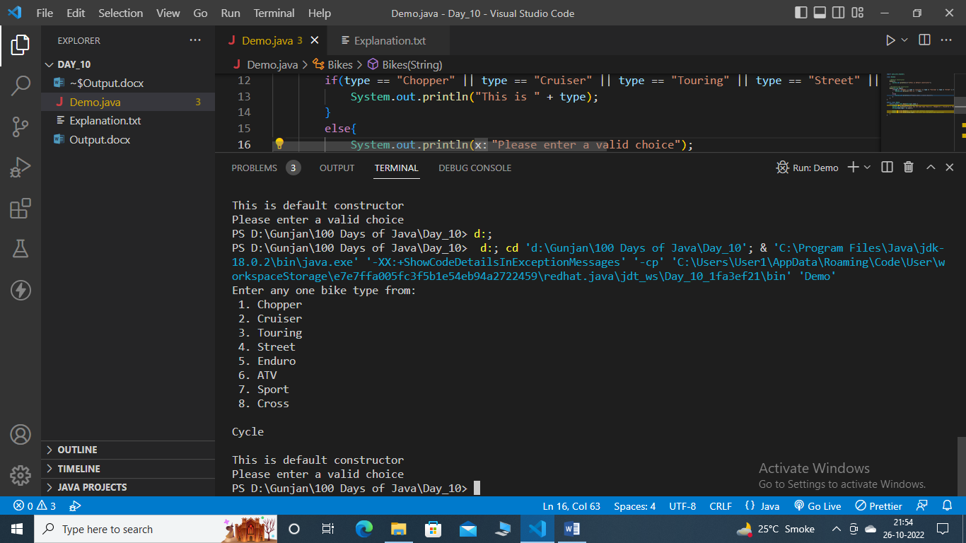

Case 2: Apart from available choices



Case 3: Symbol/ Digit/ Null

